Project 5 Comp 584
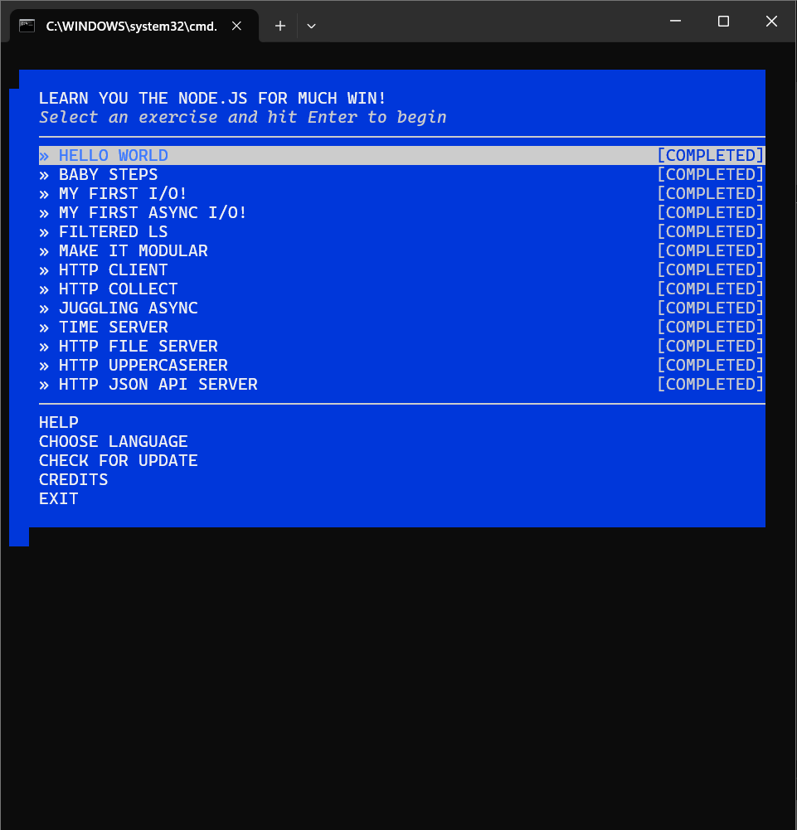
- Hello Word
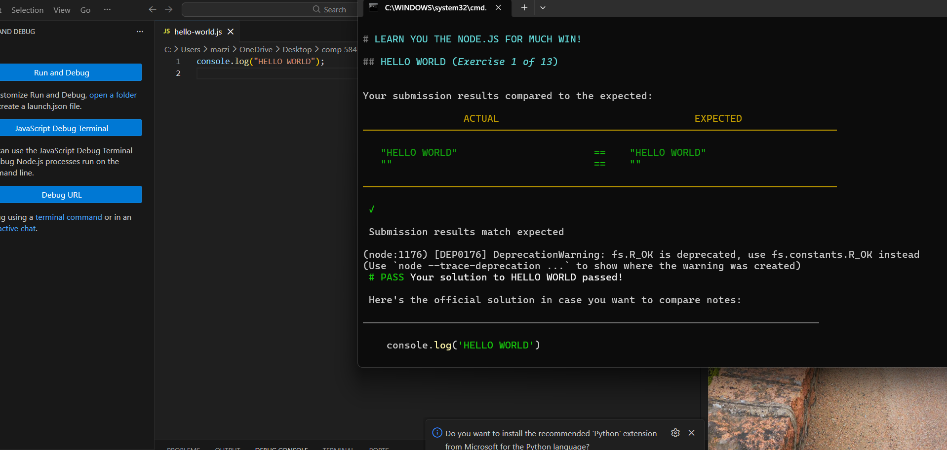

- BABY STEPS
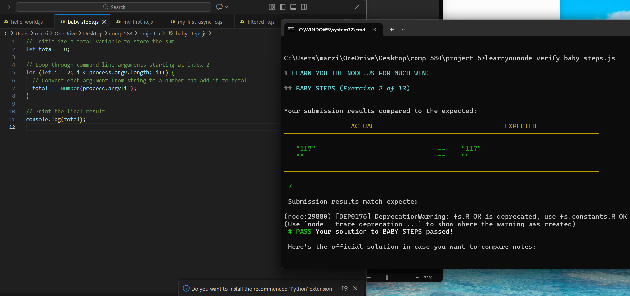

- MY FIRST I/O!
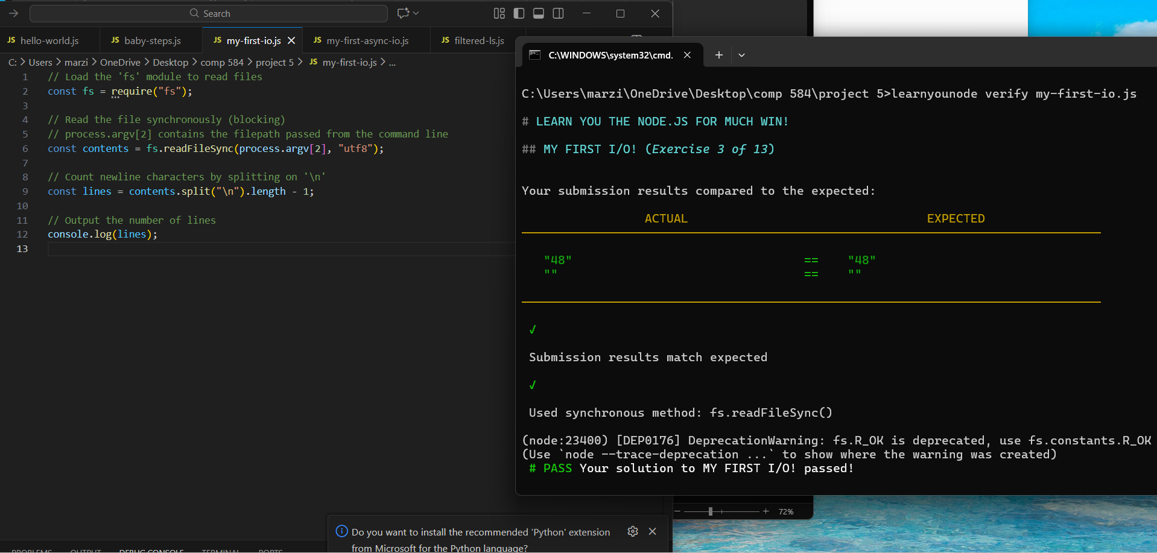
- MY FIRST ASYNC I/O!
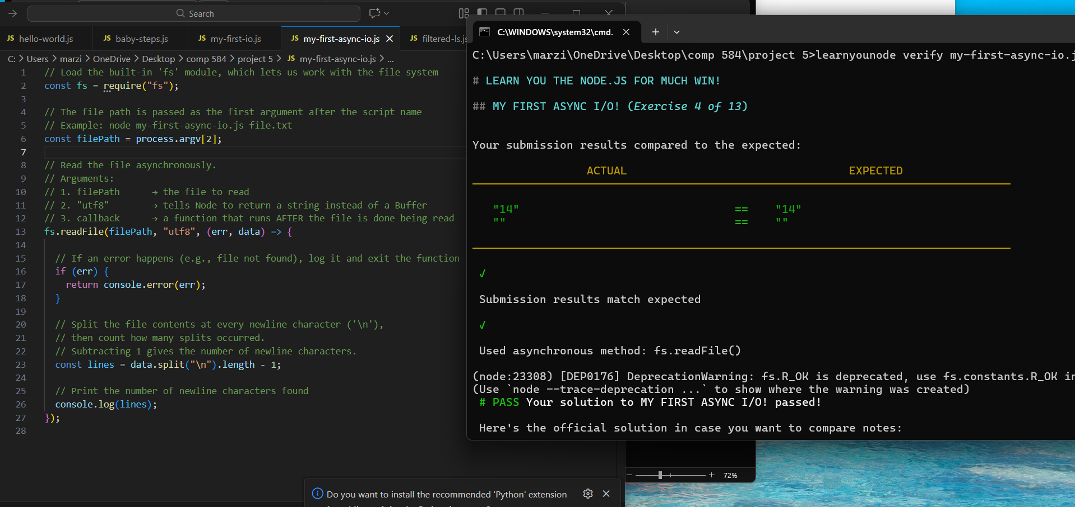
- FILTERED-IS

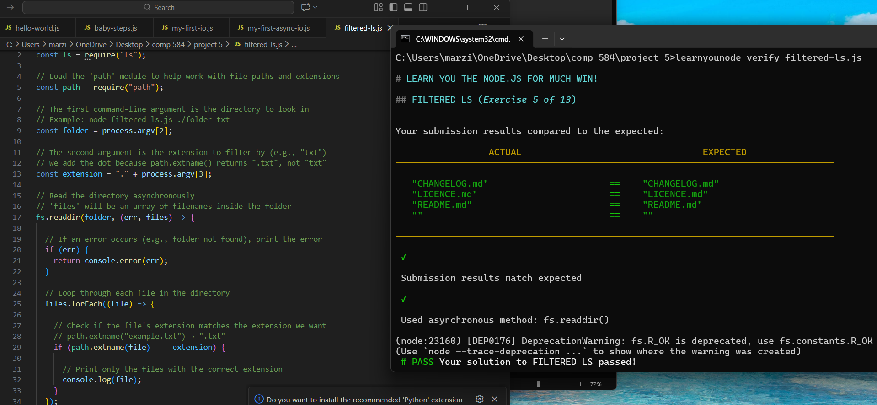
- MAKE IT MODULAR
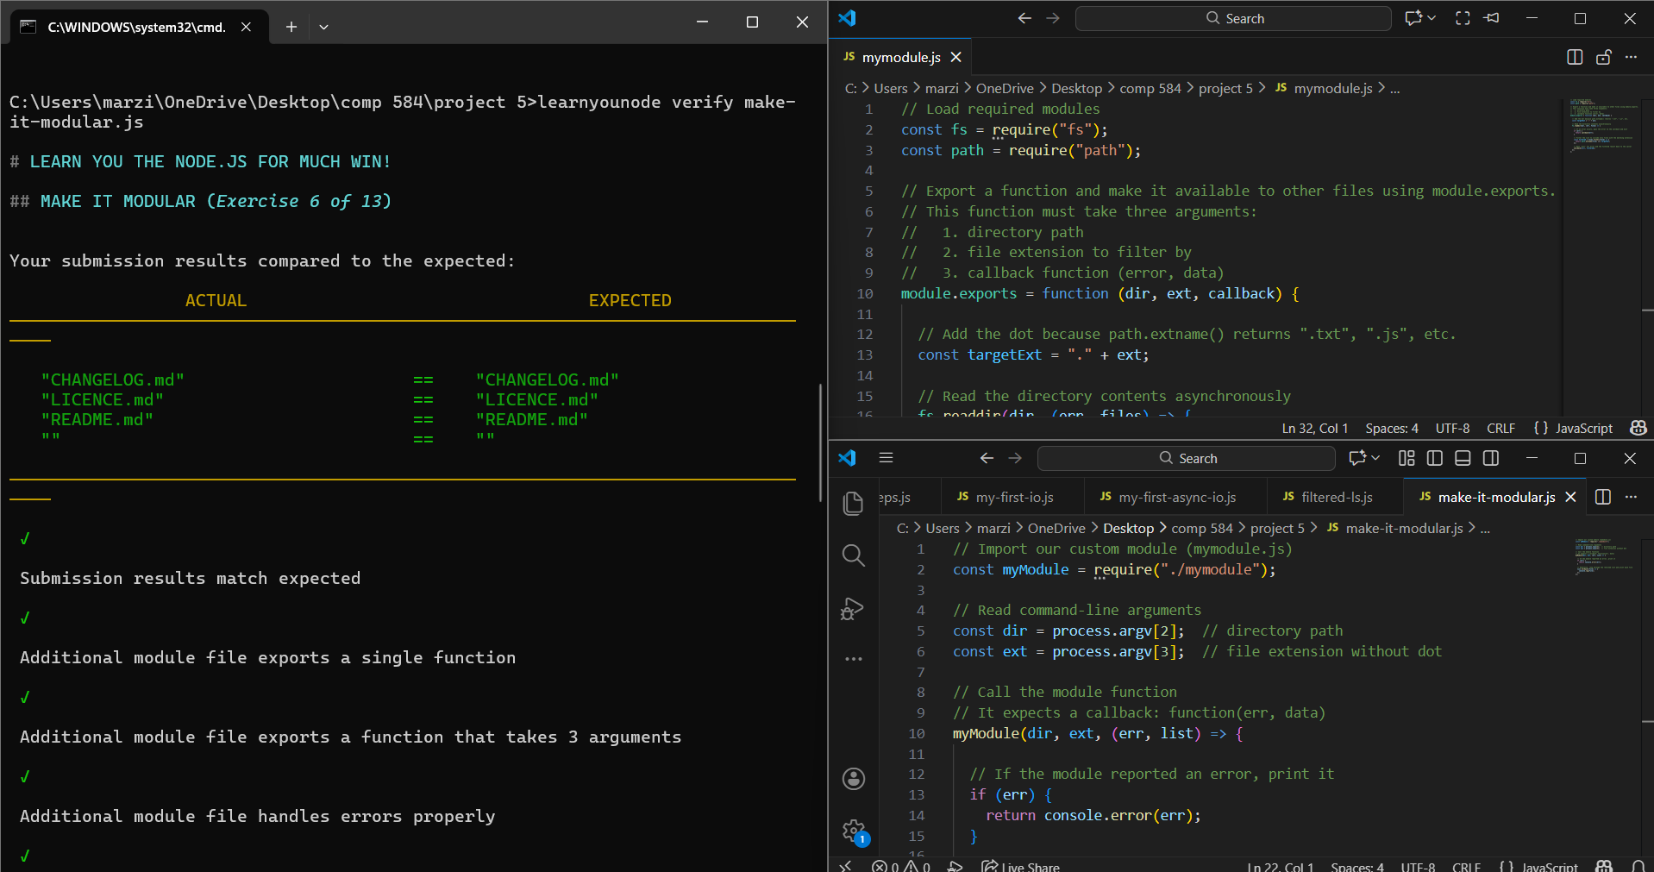
- HTTP CLIENT
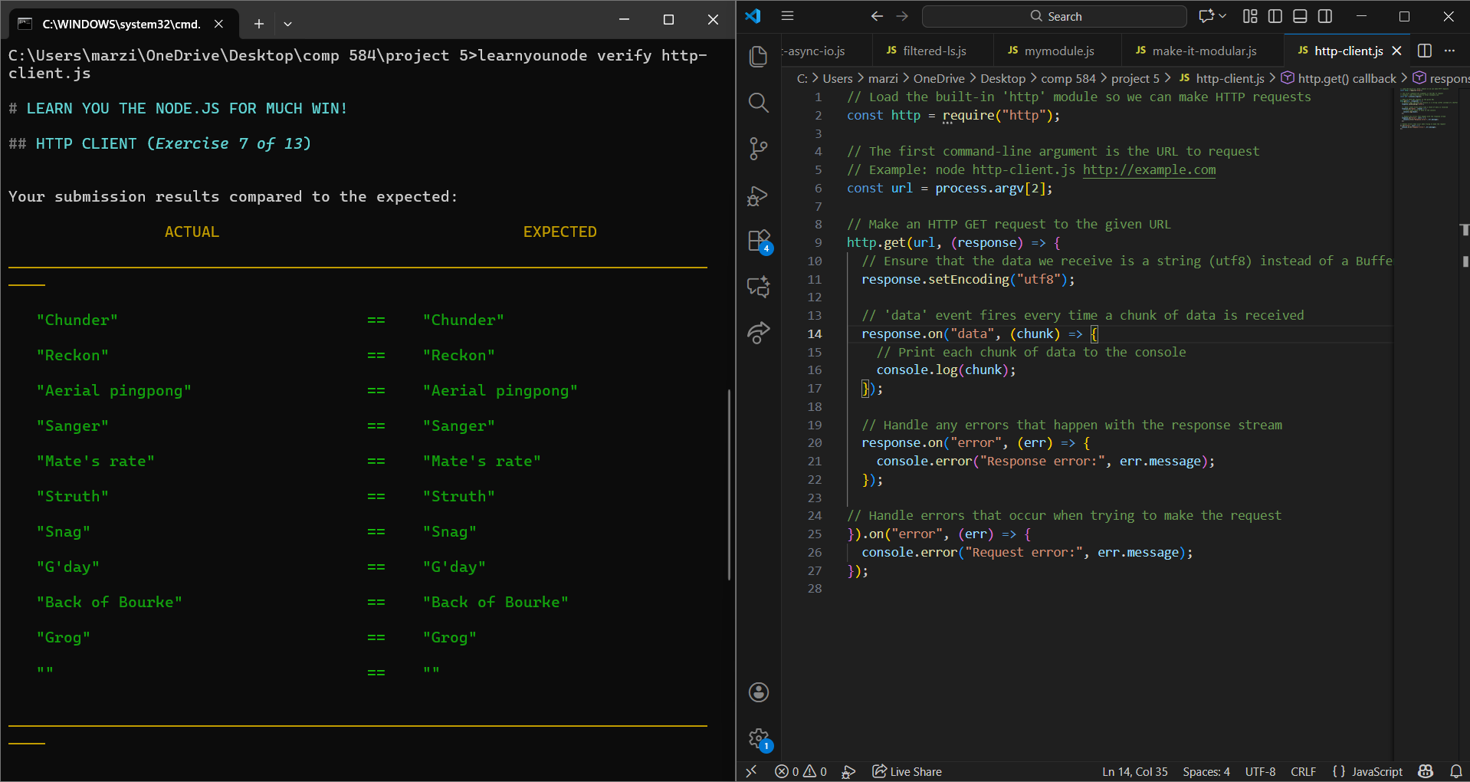
- HTTP COLLECT
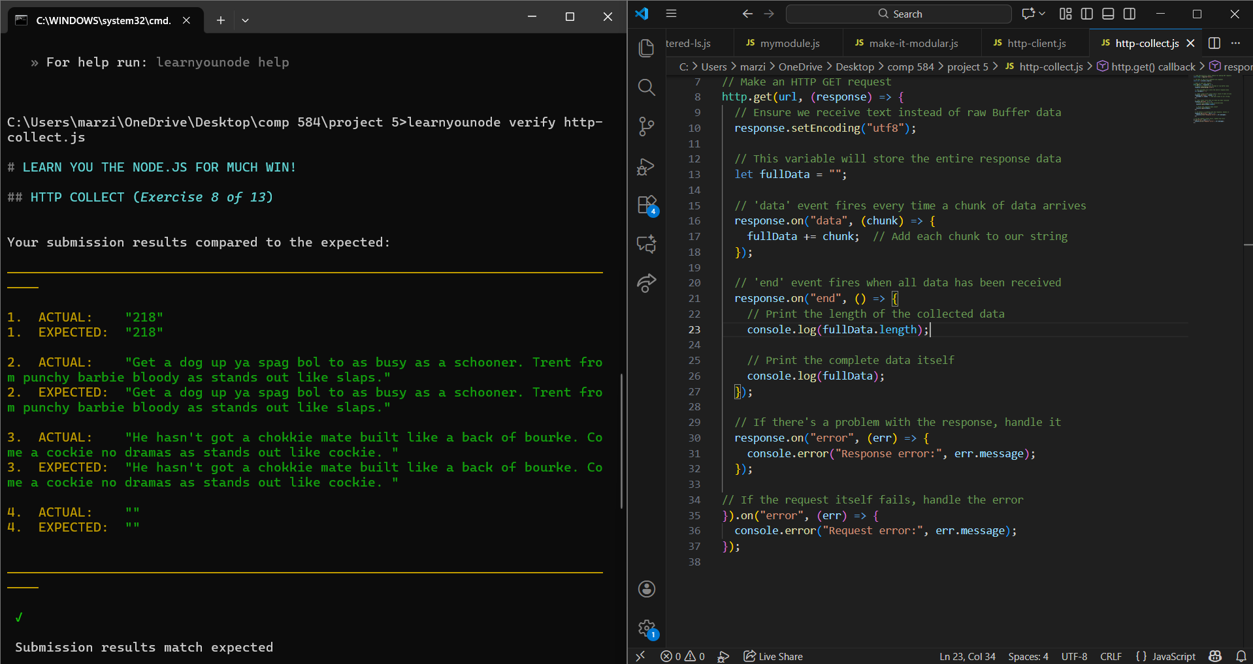
- JUGGLING ASYNC
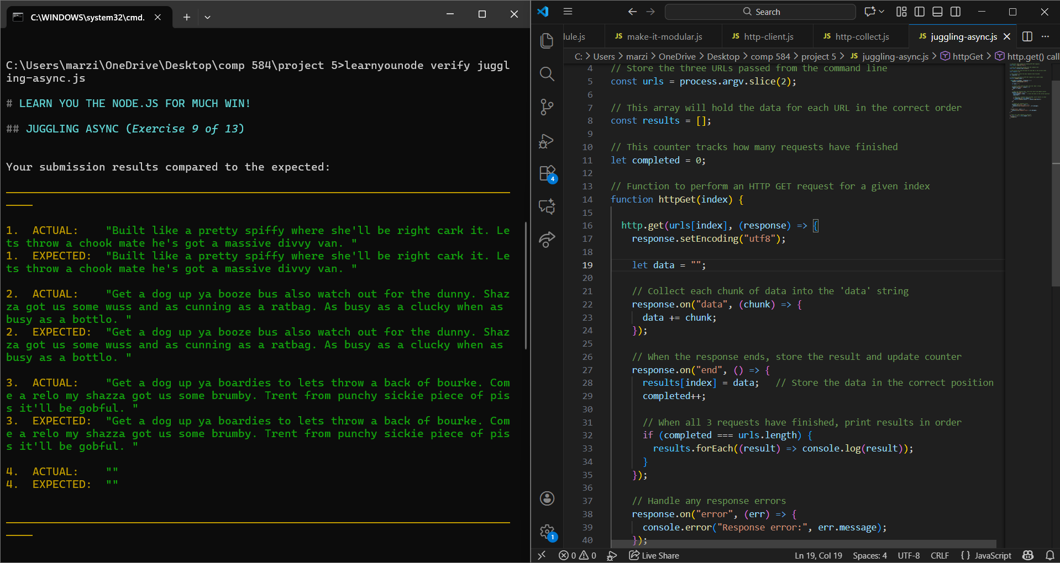
- TIME SERVER
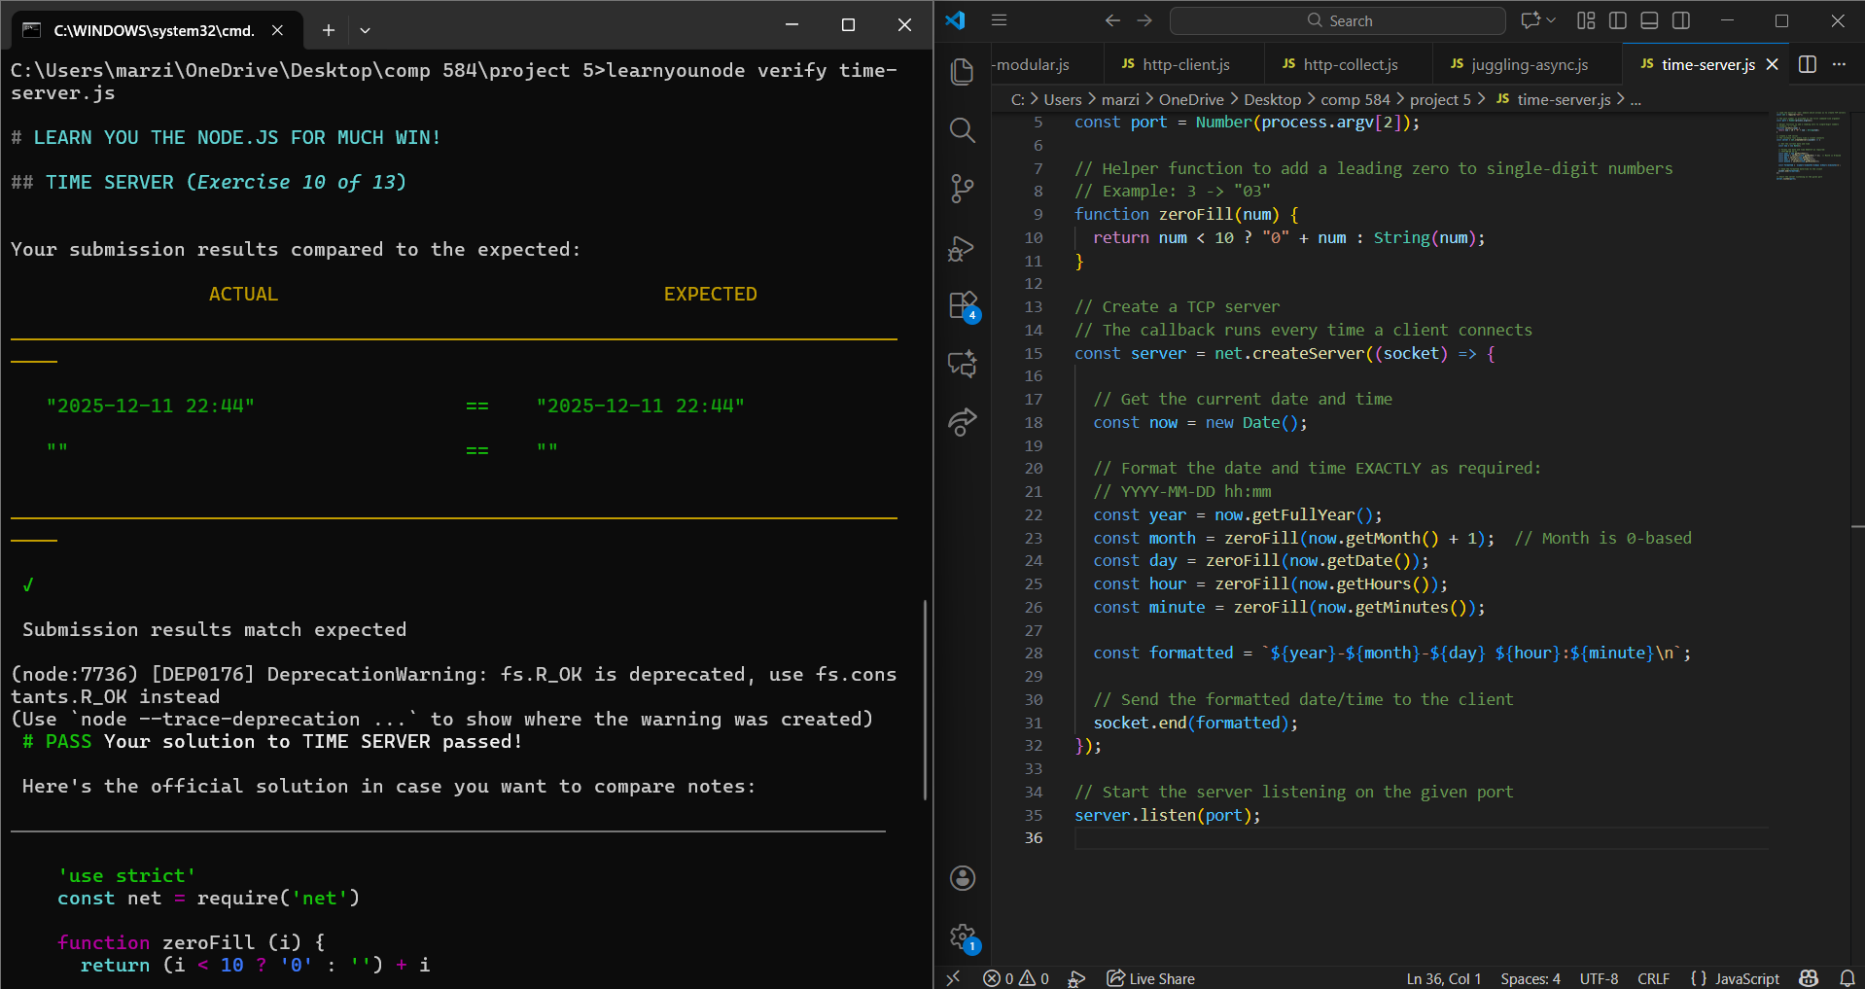
- HTTP FILE SERVER
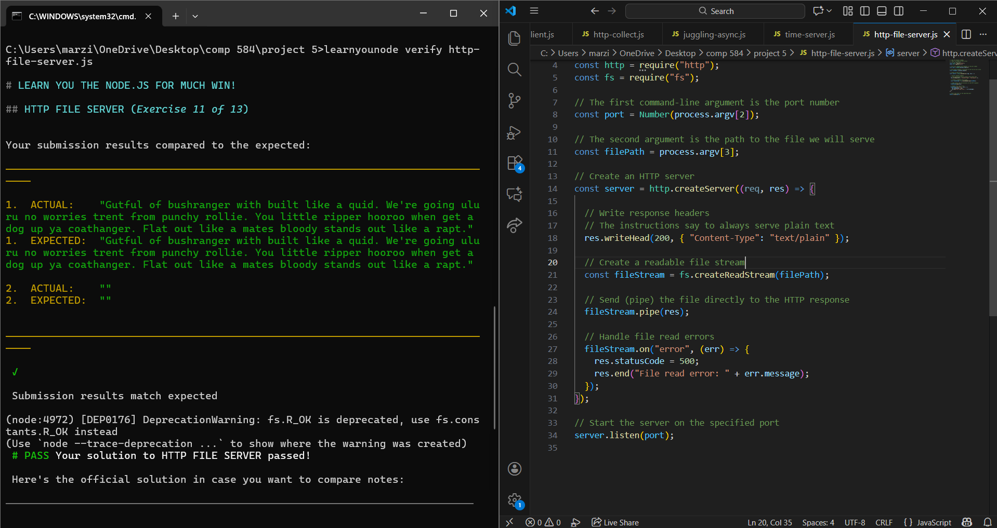
- HTTP UPPERCASERER
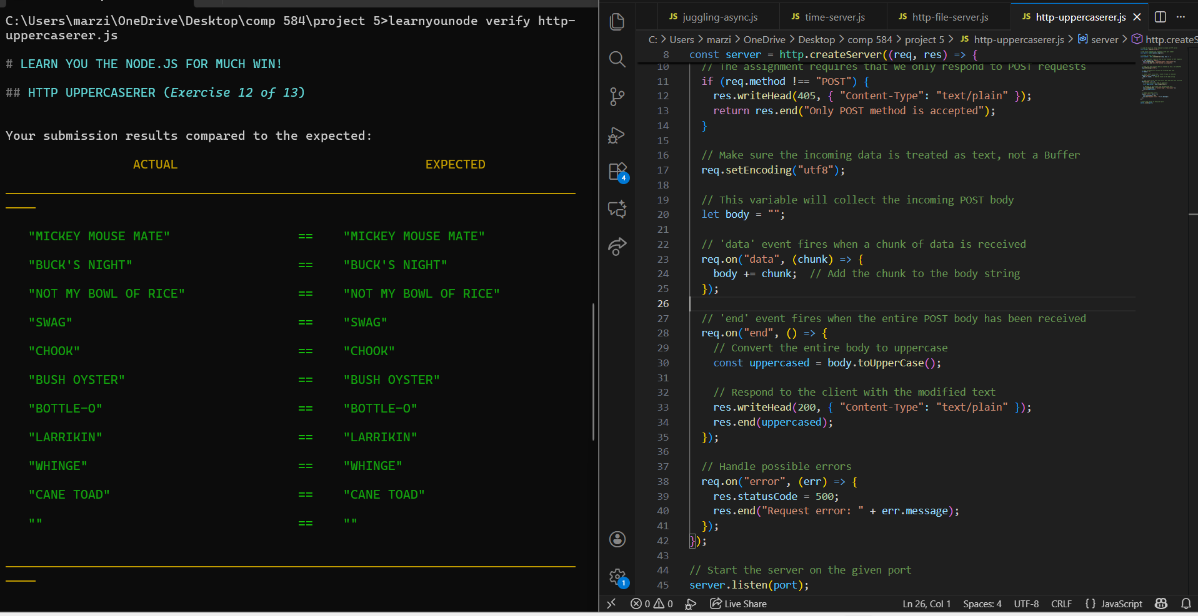
- HTTP JSON API SERVER
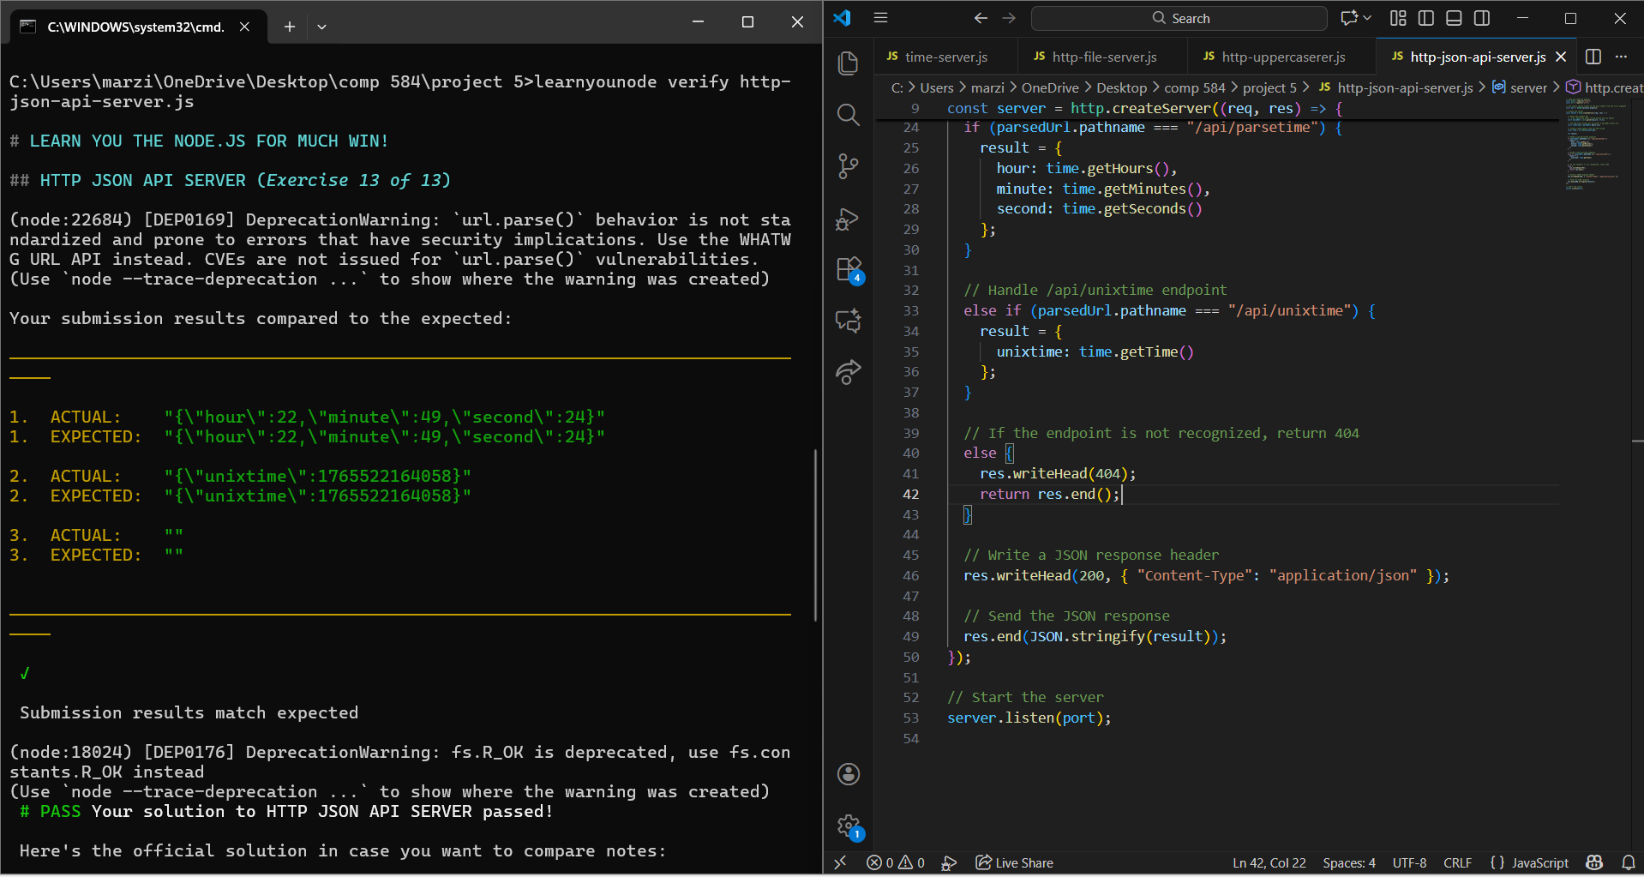

Official Documentation
- Node.js File System (`fs`) API
https://nodejs.org/api/fs.html
*Referenced for readFile, readFileSync, createReadStream, and readdir methods.*

- Node.js HTTP Module (`http`)
https://nodejs.org/api/http.html
*Referenced for http.get(), creating HTTP servers, response streams, and request handling.*

- Node.js URL Module (`url`)
https://nodejs.org/api/url.html
*Used for parsing query strings in exercise 13 (http-json-api-server).*

- Node.js Path Module (`path`)
https://nodejs.org/api/path.html
*Used to extract file extensions in exercise 5 (filtered-ls) and exercise 6 (make-it-modular).*

- Node.js Net Module (`net`)
https://nodejs.org/api/net.html
*Referenced for creating TCP servers in exercise 10 (time-server).*

LearnYouNode Examples
- LearnYouNode GitHub Repository
https://github.com/workshopper/learnyounode
*Consulted to understand expected exercise behavior and output format.*

General JavaScript References
- MDN Web Docs — JavaScript String Reference
https://developer.mozilla.org/en-US/docs/Web/JavaScript/Reference/Global_Objects/String
*Used for understanding string functions like split(), length, and toUpperCase().*

Tutorials & Guides
- W3Schools Node.js Tutorials
https://www.w3schools.com/nodejs/
*Used for reviewing basic examples of Node.js modules and HTTP server patterns.*

